The **operating system (OS) is the software that manages a computer's hardware and software resources.** Think of it as the teacher on duty, coordinating the various activities to create a harmonious (balanced) performance.

An **operating system** is the **most important software** that runs on a computer. It manages the computer's **memory** and **processes**, as well as all of its **software** and **hardware**. It also allows you to **communicate** with the computer without knowing how to speak the computer's language. **Without an operating system, a computer is useless**.

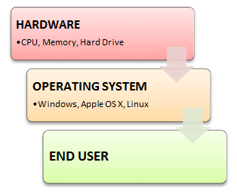

**Functions of Operating System**

Some typical operating system functions may include managing memory, files, processes, I/O system & devices, security, etc.

Below are the main functions of Operating System:

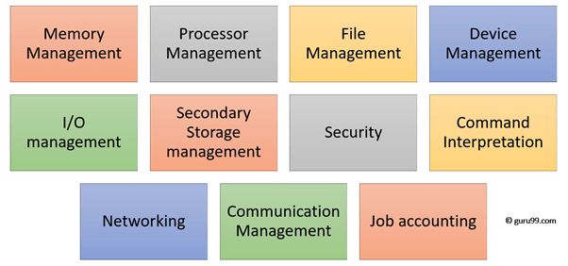

In an operating [system software](https://www.guru99.com/difference-system-software-application-software.html) performs each of the function:

1. **Process management**: Process management helps OS to create and delete processes. It also provides mechanisms for synchronization and communication among processes.
2. **Memory management:** Memory management module performs the task of allocation and de-allocation of memory space to programs in need of this resources.
3. **File management**: It manages all the file-related activities such as organization storage, retrieval, naming, sharing, and protection of files.
4. **Device Management**: Device management keeps tracks of all devices. This module also responsible for this task is known as the I/O controller. It also performs the task of allocation and de-allocation of the devices.
5. **I/O System Management:** One of the main objects of any OS is to hide the peculiarities of that hardware devices from the user.
6. **Secondary-Storage Management**: Systems have several levels of storage which includes primary storage, secondary storage, and cache storage. Instructions and data must be stored in primary storage or cache so that a running program can reference it.
7. **Security**: Security module protects the [data and information](https://www.guru99.com/difference-information-data.html) of a computer system against malware threat and authorized access.
8. **Command interpretation**: This module is interpreting commands given by the and acting system resources to process that commands.
9. **Networking:** A distributed system is a group of processors which do not share memory, hardware devices, or a clock. The processors communicate with one another through the network.
10. **Job accounting**: Keeping track of time & resource used by various job and users.
11. **Communication management**: Coordination and assignment of compilers, interpreters, and another software resource of the various users of the computer systems.

**Historical Dating:**

* **Early 1950s:** The first operating systems began to emerge, initially designed for mainframe computers. These early systems were simple, often batch-oriented, and focused on managing the execution of programs.
* **Late 1960s:** The development of time-sharing systems allowed multiple users to interact with a single computer simultaneously. This led to the emergence of more sophisticated operating systems.
* **1970s and 1980s:** The rise of personal computers saw the development of user-friendly operating systems like CP/M and MS-DOS.
* **1990s:** Graphical user interfaces (GUIs) became popular, making computers more accessible to a wider audience. Operating systems like Windows, macOS, and Linux gained prominence.
* **21st century:** The mobile revolution led to the development of operating systems specifically designed for smartphones and tablets, such as iOS and Android.

**In essence, an operating system is the foundation upon which all other software applications run. It provides a user-friendly interface, manages system resources, and ensures that hardware and software components work together seamlessly.**